SET 4

Q1. (Algorithms – 5 Marks)
Use AI to generate Python code for Bubble Sort and Insertion Sort.
Compare their execution time using Python's time module.
CODE:
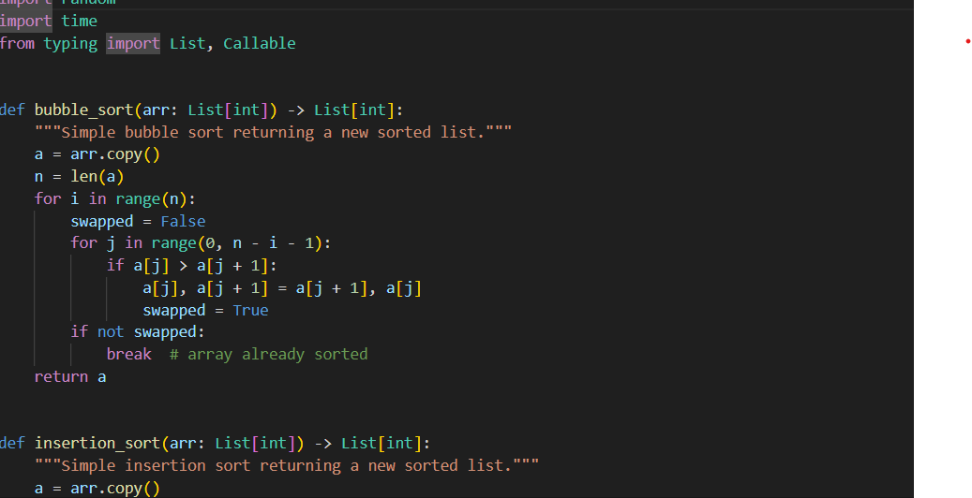
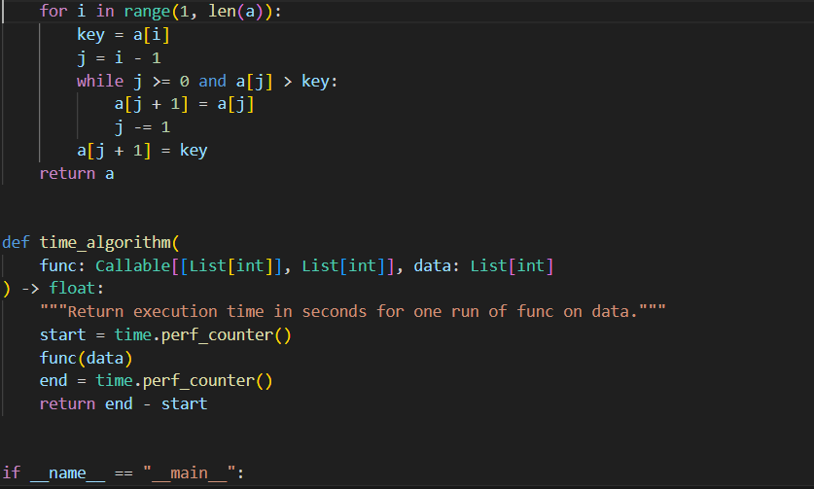
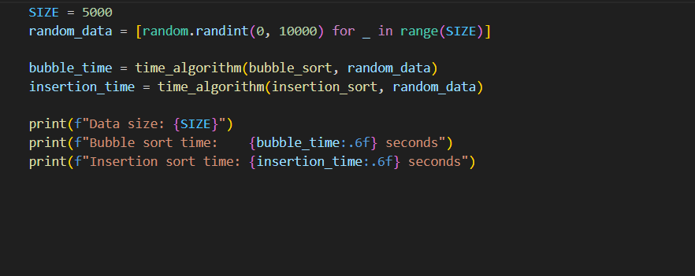
OUTPUT:
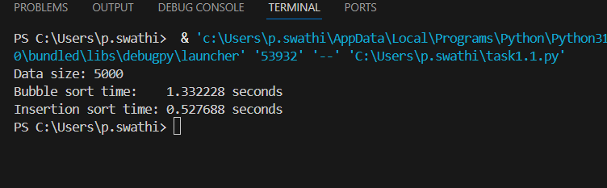

Q2. (Web Frontend – 5 Marks)
With AI help, create a webpage showing a dynamic product list using JavaScript arrays.
Each product must display:
- Name
- Price
- "Add to Cart" button
Code:
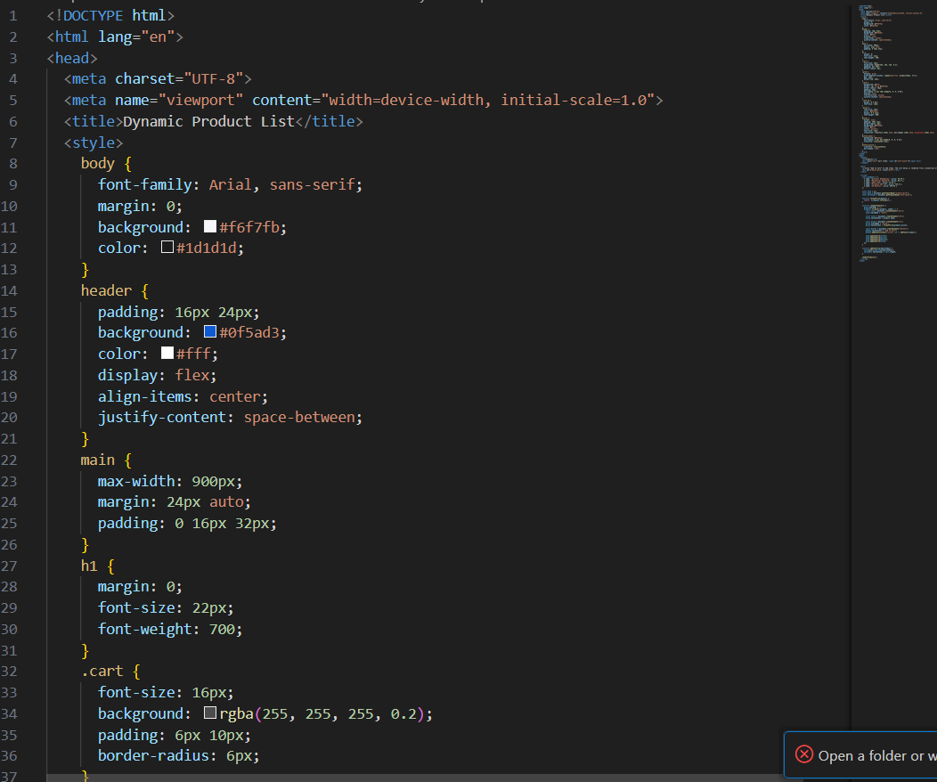
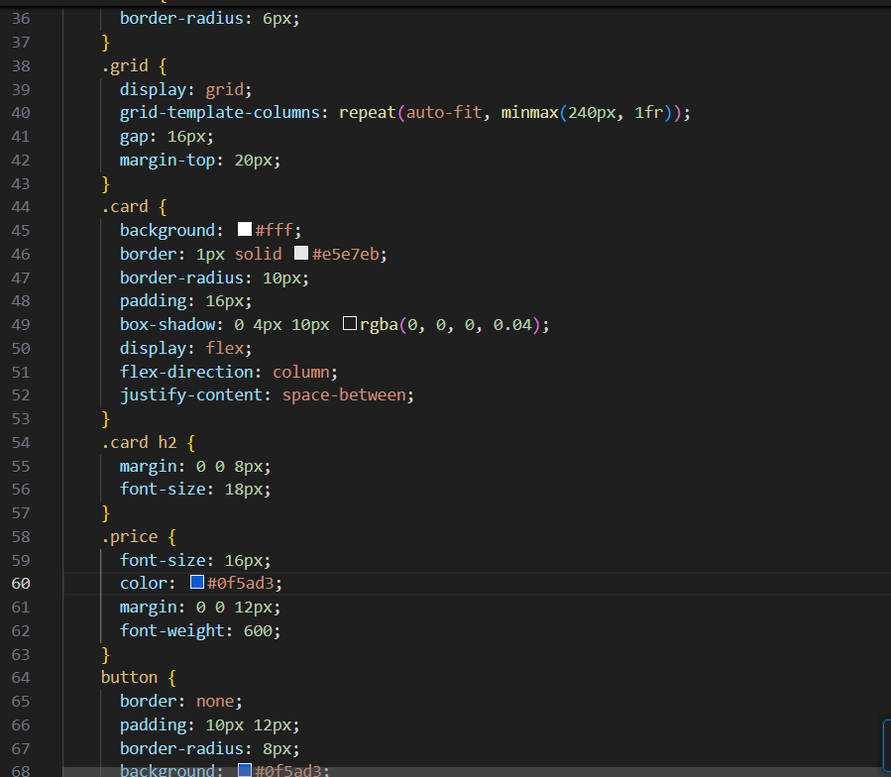
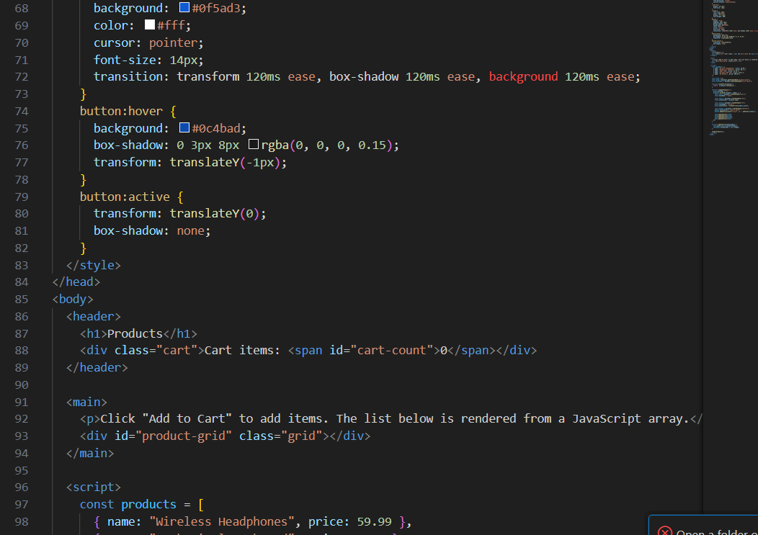
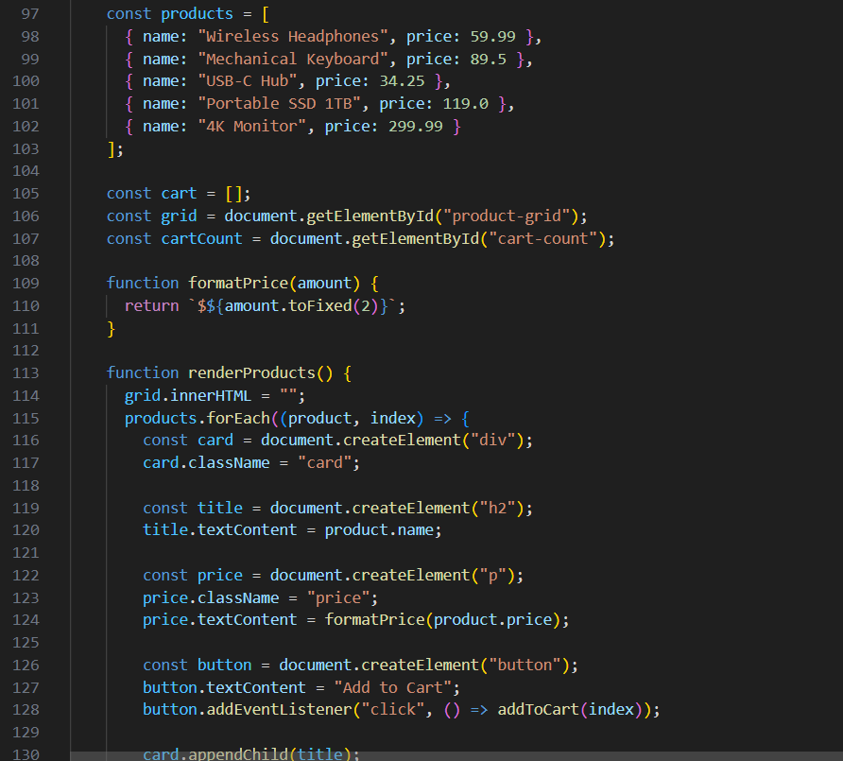
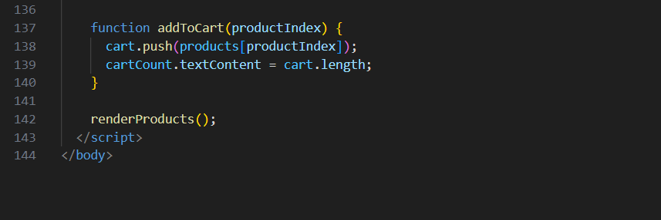
output
